
Chemistry and chemicals competencies and study course Luisetto M. at 2026 In chemistry field
LEVEL OF EDUCATION : 8 EQF LEVEL
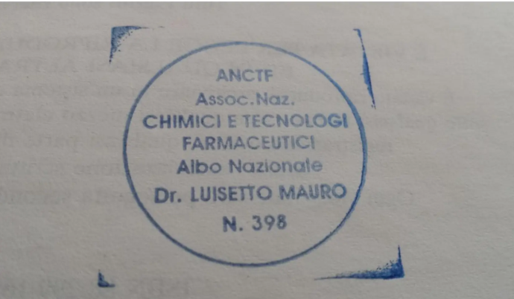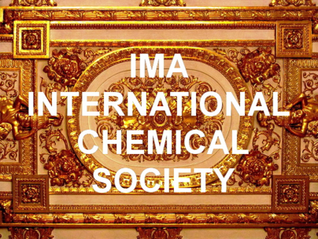
( ANCTF -Past membership)
University course , updating course , working experience , Laboratory practice , research activities and other of interest
DEGREE IN PHARMACY 1995 Turin university : equiparated by Italian law to 5 year degree in chemistry and technology pharmaceutical and title allowed to participate to State examination for chemists positions.
APPLIED PHARMACOLOGIST – PAVIA UNIVERSITY TITLE equipollent to the specialization in toxicology
Managerial course – UNIPARMA COMPLEX UNIT HEALTHCARE

Nota esplicativa:
I titoli accademici, i master, i dottorati e i riconoscimenti di natura internazionale o onorifica indicati nel presente curriculum (rilasciati da istituzioni, accademie o enti esteri) hanno esclusivamente valenza culturale, associativa e onorifica internazionale. Tali riconoscimenti non vengono presentati come titoli di studio aventi valore legale o equipollenza automatica ai sensi dell'ordinamento universitario italiano (MUR), né sostituiscono i titoli abilitanti previsti dalla legge italiana per l'esercizio delle professioni regolamentate. Tutte le attività di studio, le pubblicazioni, i riconoscimenti e i percorsi di approfondimento scientifico menzionati nel presente curriculum si intendono svolti ed enunciati nel pieno rispetto delle competenze professionali riservate dalla legislazione italiana alle professioni regolamentateIl presente documento ha esclusivamente finalità informative, culturali, di ricerca scientifica indipendente e di aggiornamento professionale, e non costituisce in alcun modo rivendicazione di abilitazioni, iscrizioni ad albi professionali o esercizio di attività riservate per legge a soggetti muniti di specifici titoli abilitanti.

Master of science in CHEMISTRY AND CHEMICAL PRODUCTS IMA ACADEMY -2025- honorific
Phd in CHEMICALS AND PHARMACEUTICAL IMA ACADEMY – of international value 2025 – honorific ( for graduated in Other discipline then chemistry : pharmacy , biology or medicine ) - 1 YEAR LONG
Degree in CHEMISTRY AND PHARMACY 2026 IMA academy ( after recognizement of all previous university studies or equipollent, working activities in the field , all other course followed in the career and publication)-honorific
Visiting Professorship INDUSTRIAL CHEMISTRY and APPLIED CHEMISTRY – IMA academy – honorific 2025-2026
Visting Professorschip Environmental Toxicology S. George S. Italy – honorific
CYPRESS international university – Malawi satellite – Doctorschip in pharmacology
Honorific
1999 ANCTF MEMBERSHIP ( TEN YEAR) ITALIAN NATIONAL ASSOCIATION CHEMISTS AND TECHNOLOGY PHARMACEUTICAL
1999 APPOINTMENT as ANCTF - REGION PIEMONTE REPRESENTATIVE - Italian national association of chemists and technologist pharmaceutical

1)Udemy courses:

- SAFETY in STORAGE and HANDLING OF CHEMICALS 21 JULY 2025- on line
- CHEMICAL CALCULATION IN CHEMISTRY JULY 2025
- CHEMICAL technology-process technology july 2025
- DISPERSED SYSTEMS JULY 2025
- GEOLOGY : Earth Science for Everyone
- Electrochemistry course 2025 august

ALISON courses
The basic science of METALLURGY july 2025
Essentials of GEOLOGY august 2025
Advanced chemistry : Polimerisation august 2025
Petroleum engineereging: Principles and concepts august 2025
ISO 29001 – QUALITY MANAGEMENT SYSTEM for oil and gas -august 2025

2) Webinar on demand METTLER TOLEDO july 2025
-FUNDAMENTALS OF PH --ON DEMAND – WHAT IS PH ?
-SEMINARIO ON LINE SULLE BASI PER UNA PESATA PERFETTO
-NORMATIVE DELLA FARMACOPEA PER LE ACQUE AD USO FARMACEUTICO
-METODI DI PROTEZIONE PER LE AREE A RISCHIO DI ESPLOSIONE
-WEBINAR HAZARDOUS AREA REGULATION
Other courses
CHEMICAL RISK IN HOSP LABS - 2001 provider AZIENDA OSP. SAN GIOVANNI B. TO provider SPP - FORMAZIONE E AGGIORNAMENTO
Certificate for managers Italian Safety rules in working settings : IL Dlgs 81 / 08 e- learning durata ore 16 con test da remoto attestato di SPP AREA PC del 24-5-2020

SCIENTIFIC SOCIETY MEMBERSHIP

1)SUSCHEM sustainable chemistry –form may 2024
2)Chinese Chemical Society: Dr. Luisetto held a membership for the 2024–2025 term.
3)IAENG 2024 member International Association of ENGINEERS whit n. 375456
4)Setac MEMBER Society of Environmental Toxicology and Chemistry 2024-2025
5)COMMONWEALTH CHEMISTRY – REGISTRATION 2024
6)ANCTF PAST MEMBERSHIP 10 YEARS: Italian National association of chemists and pharmaceutical technologist in ROME ( past REGIONAL REFERENT for PIEMONTE REGION FOR RELATIONSHIP WITH THE UNIVERSITY )
7) EC4 registered European Specialist laboratory Medicine 2014-2019 ( European Comunities Confederation of Clinical chemistry and Laboratory medicine )
8) MAY 2026 Secretary at IMA international chemical society
9) Wased academy WORLD ACADEMY OF SCIENCE ENGINEERING AND TECHNOLOGY WASET : International Scientific Committee of Pharmacological and Pharmaceutical International Standard Name Identifier (ISO 27729) ISNI:0000000091950263 Discipline Chemical and Materials Engineering
COURSE ATTENDANCE : free
From 2007 to jan 2008 as pharmacist in UNIT of ANALYTICAL CHEMISTRY OSP MOLINETTE TURIN ( in this lab. Where performed toxicological chemical analysis of first and second level)
Chemical laboratory attendance during degree course in pharmacy and in Technicians chemical and biological field .
UNIVERSITY CHEMISTRY COURSE AND OTHER :
In physics, chemical biology , organic chemistry inorganic chemistry , analytical chemistry
Preparation and extraction chemical laboratory for drugs preparation , chemical toxicology and chemistry of food products and chemical of dietological products
PRACTICAL LABORATORY EXPERIENCE : more then 1 year in field of
Gravimetric assay , Flame inorganic assay , qualitative assay , Quantitative methods , titulations , Photometric assay , Turbidimetric assay , Electrophoresis HPLC , Atomic absorbtion assay , Kinetics of reaction , Biochemistry , chromatographic methods, instrumentals chemical analysis , Ph meter , separation methods , extractions , solubilitazion .
Chemical reagents , radio immunometric assay , immune enzymatic test, monoclonal antibodies tests , Elisa test , chemio- luminescence , polarimetry , electrochemical techniques latex agglutination tests , sampling methods , sample preparation and other
MULTIANNUAL EXPERIENCE IN PRODUCTION OF CHEMICAL REAGENTS IN GALENIC LABORATORY AS PHARMACIST ( CAUSTICS, ACID, COLORANTS, DISINFECTANTS , LAB. REAGENTS , ALCOOL SOLUTION , SUSPENSION , GELS , POWDERS AND OTHER .
MULTIANNUAL EXPERIENCE AS PHARMACIST INVOLVED IN PROCUREMENTS OF RADIO DRUGS IN AN PUBLIC HOSPITAL

2025 DECEMBER OFFICIAL ROLE IN ( RE ) FUNCTION EXECUTIVE RESPONSIBLE MANAGER OF MEDICINAL GAS SYSTEM PC AREA HOSP
(NEEDED CHEMICO-PHARMACEUTICAL COMPETENCIES)
TEN YEAR EXPERIENCE AS QUALITY CONTROL HOSPITAL MEDICAL GASES
PC AREA HOSP ( ABOUT 700 BEDS – THREE HOSP LINKED )
Executive Manager for the IGDM hospital medical gases Power Plant Maintenance Contract, quality control medical gases
PREVIOUS LABORATORY EXPERIENCE AS LABORATORY TECHNICIANS
CHEMISTRY AND BIOLOGICAL( PRIVATE LABORATORY IN TURIN 13 YEAR AND PUBLIC HOSPITAL TURIN 14 YEAR )- EXPERIENCE ALSO IN CHEMICAL ANALYSIS
2025 TUTOR IN THE INTERNAL COURSE NON STERILE CLINICAL GALENIC- SECOND LEVEL – 30 CREDITES ECM – PC AREA HOSP
IMA Marinksya academy : industrial and Applied Chemistry Branch
Honorific title
EXPERT ON THE FIELD OF "CHEMISTRY" of International Mariinskaya Academy 2025
Falcon academy membership 2022 : for contributions in the field of chemistry and pharmacology
Academic :
Secretariat IMA university 2025
Presidency courses ADVANCED STUDIES IN CHEMISTRY AND PHARMACY IMA university 2025
Society :
International IMA CHEMICAL SOCIETY 2026 : President , General secretary Prof Latyshev O.YU, scientific coordinator Prof.dr. Khaled EDBEY -NO PROFIT , NOT REGISTERED ORG

SELF IMPROVEMENT :

Molecular biology- PCR and other technology - book free studies
Elementi di CHIMICA FISICA Peter William Atkins Julio de Paula 2018
FONDAMENTI DI CHIMICA INDUSTRIALE – Cavani Zanichelli 2022
Tecnologia chimiche industriali -Natoli Calatozzolo
CHIMICA AGRARIA autori TAGLIAFERRI GRANDE
Publication in chemistry fields

1) Luisetto M. Artificial Intelligence (AI) in the Chemical Field: Innovation and Risk Evaluation. Ann Adv Chem. 2025; 9(1):027-033. Available from https://dx.doi.org/10.29328/journal.aac.1001057 – INDEXED BY HARVARD DIGITAL LIBRARY
(PDF) ANNALS OF ADVANCES IN CHEMISTRY - Artificial Intelligence (AI) in the Chemical Field: Innovation and Risk Evaluation. Available from: https://www.researchgate.net/publication/394576155_ANNALS_OF_ADVANCES_IN_CHEMISTRY_-_Artificial_Intelligence_AI_in_the_Chemical_Field_Innovation_and_Risk_Evaluation [accessed Aug 22 2025].
Acceptance letter 2nd WORLD CONGRESS ON CHEMISTRY 2025 DUBAI- Inovine
Artificial Intelligence (AI) in the Chemical Field: Innovation and Risk Evaluation.
2)The Inorganic impurity for injectable WATER ,chemical DRUGS and biopharmaceuticals : Conductivity TOC and Activated charcoal - graphene testing in Quality control- Hypotesys of work
3)Luisetto M, Khaled EDBEY, Gamal A. Hamid, Mashori Gulam Rasool, Benzi Cipelli R. , Cabianca L. , OLEG Yurevich Latyshev 2024 ISAR Journal of Multidisciplinary Research and Studies vol 2 issue 4
AMORPHUS SUBSTANTIE (ACTIVATED CHARCOAL) AND OTHER IMPURITIES IN API MANUFACTURING PROCESS. PHARMACEUTICAL, TOXICOLOGICAL AND REGULATORY IMPLICATION wjpr October 2023Luisetto M., Edbey K., Nili B. Ahmadabadi, Riccardo Benzi Cipelli, Farhan Ahmad Khan, Mashori Gulam Rasool and Oleg Yurevich Latyshev World journal of pharmaceutical research
4)Luisetto M, Ahmadabadi NB, Khaled EDBEY, et al. Next generation tools in m RNA purification: The role of continous Raman spettroscopy testing with pretreatement of the sample. Scholastic Medical Science 2.2 (2024): 1-2.
5)Mauro Luisetto, Nili B. Ahmadabadi, Edbey khaled Edbey K, Gamal A. Hamid, Cabianca L, et al. (2022). Raman ( Rs)Spettroscopy For Biopharmaceutical Quality Control and PatRaw Material - Final Products : The Nanolipids Effect On Signal IntensityRegulatory and Toxicological Aspects, World J Clin Med Img,1(1): 46-61.
6)luisetto M (2022).Graphene and Derivates: Physico-Chemical and Toxicology Properties in the mRNA Vaccine Manifacturing Strategy . Sci World J Pharm Sci, 1(2);1-23
7)Research article Hospital Medicine Gas Management System: The Pharmacist Role in a Pharmaceutical- Chemistry Setting-Results of a Practical Experience in an Advanced Country Opast Advances in Bioengineering & Biomedical Science Research ISSN: 2640-4133 Volume 2 | Issue 3 | 1 of 10
8)International Invention of Scientific Journal Available Online at http://www.iisj.in e-ISSN: 2457-0958 Volume 05|Issue 01|January, 2021| Page | 31 CHEMICO- PHYSICALS PROPERTIES OF CORONAVIRUS AFFECTING AIRBORNE TRASMISSIBILITY
9)Mauro Luisetto, Nili B. Ahmadabadi, Zaineb O. Ettarhouni, Edbey K and Latyshev OY. (2022). Monoliths in the mR.N.A. Vaccine Purification Process the Silica Resin and other Composite Materials : the Carbon Content. Journal of Pharmacy and Drug Development 4(1).
10)Contrast Agents, Radiodiagnostics-Radiodrugs and AI Implications- A Key Reading for a Complex World Luisetto M, Edbey K, Hamid GA, Rasool MG, Rinaldi G, Ferraiuolo A, Fiazza c, Cabianca L, YuLO July 19, 2024 Current Trends in Pharmacology and Clinical Trials (CTPCT) FIRST PRICE RECOGNITION
11)E- Poster abstract IMAGING , CONTRAST AGENTS, RADIOPHARMACEUTICALS AND THE CLNICAL PHARMACIST ROLE IN 2019 : National seminar recent trends in radiopharmaceuticals in drug discovery quality , safety, and regulatory perpesctive 2019 Himachal pharmacy college india
12) Luisetto m et al Next Generation Tools in mRNA Purification: The Role of Continuous Raman Spectroscopy Testing with Pretreatment of the Sample. (2024). Medicinal & Analytical Chemistry International Journal, 8(`1), 1-3. https://doi.org/10.23880/macij-16000190
Self-Assembling Property of Graphene Derivates Chemico - Physical and Toxicological Implications- Book 2022 ISBN-10, 6205497107 ; ISBN-13, 978-6205497104.
13)La gia’ denominata laurea in Chimica e Farmacia e le competenze del chimico-farmacista - equipollenze ed equiparazioni di legge Legge 21 giugno 1964 n. 465 Rassegna di normativa di interesse Quinta edizione integrate 2024 ISBN 978-1-4457-3271-8 lulu Book
14)Luisetto M, Public Hospital Gas Management System: Health, Risk, Economic Implication – A Practical Experience 2015-2020.
IJCMCR. 2020; 2(4): 004 DOI: 10.46998/IJCMCR.2020.02.000044
15)Research article Hospital Medicine Gas Management System: The Pharmacist Role in a Pharmaceutical- Chemistry Setting-Results of a Practical Experience in an Advanced Country Opast Advances in Bioengineering & Biomedical Science Research ISSN: 2640-4133 Volume 2 | Issue 3 | 1 of 10
16) acceptation letter j. AMERICAN JOURNAL OF PHYSICAL CHEMISTRY AJPC august 2025 research article ARTIFICIAL INTELLIGENCE IN CHEMISTRY : EVALUATING INNOVATIOONS AND RISKS IN RESEARCH AND APPLICATIONS .
17) The Presidium of the IMA approves the publication of the scientific work of Dr. Mauro Luisetto at al. "CHEMISTRY and CHEMICALS : KNOWLEDGE SKILLS - COMPETENCIES CHEMISTRY IN THE GALENIC LABORATORIES : AN HISTORICAL ANALYSIS , NORMATIVE RULES AND IMPLICATIONS" November 2025 2025.04.11. Reg. №: 1624-2025.
18) CHEMISTRY IN THE GALENIC LABORATORIES: AN HYSTORICAL ANALYSIS, NORMATIVE RULES AND IMPLICATIONS Luisetto M, Edbey k et al wjaps ISSN: 3049-3013 Volume 2, Issue 4, November 2025 E- book
19) article first author International Journal of Chemistry and Chemical Processes E-ISSN 2545-5265 P-ISSN 2695-1916,Vol 12. No. 3 2026 www.iiardjournals.org online version2026 march 25
20)The hospital medical gases management and the chemistry word . DOI: 10.56201/ijccp.vol.12.no3.2026.pg9.26
21) e-BOOK pubblicato lulu.com : Laurea in “CHIMICA E FARMACIA” – equivalenze -Equiparazioni –equipollenze 2026 may
22) E-book LE COMPETENZE CHIMICHE NELLA STORIA DEI CHIMICI-FARMACISTI NEGLI ULTIMI DUE SECOLI IN ITALIA ED IN EUROPA may 2026 Amazon editor
23) E-book HYSTORICAL AND LEGAL EVOLUTION OF CHEMISTRY AND PHARMACY DEGREES IN ITALY 19-20 TH CENTURY – knowledge and competencies-Amazon editor may 2026
24)e-book : Programmi corso di laurea in chimica e farmacia –Escursus storico-Mineralogia-geologia-fisica sperimentale-chimica di guerra – CONCORSI PER CHIMICO MARINA-DOGANE –Stazioni sperimentali di CHIMICA AGRARIA -Editore Lulu.com may 2026
25) Analisi storica e normativa della laurea in chimica e farmacia con focus su equiparazioni, insegnamenti , esami di stato ed aggiornamenti legislativi fino al 2024 – Amazon self publishing- Ebook maggio 2026
26)E –BOOK LE COMPETENZE TECNICO SCIENTIFICHE DEI LAUREATI IN CTF E FARMACIA AGOSTO 2026 AMAZON SELF PUBLISHING ( SCHEMA DEL LAVORO APPROVATO DA ANCTF per pubblicazione estratto su NCF AUTUNNO 2026)
27) e- book LA SCUOLA DI FARMACIA E LA CHIMICA INDUSTRIALE ANNO 1024 edizioni AMAZON SELF PUBLISHING SETTEMBRE 2026
28) COMPETENZE DEI LAUREATI IN FARMACIA E CTF-Ambiti NON CLASSICI — Competenze nella chimica non riservate Analisi della normativa — Ipotesi di lavoro
e-book Amazon self publishing 7 ottobre 2026 Luisetto m Edbey Khaled , latyschew O. Yurevich
29) International Journal of Chemistry and Chemical Processes E-ISSN 2545-5265 P-ISSN 2695-1916,Vol 12. No. 3 2026 www.iiardjournals.org online version
The Hospital Medical Gases Management and the Chemistry World

PUBLICATIONS ( CHEMISTRY AND RELATED SCIENCE ) indexed by:
PUB MED , My NIH ,HARVARD LIBRARY , BRITISH LIBRARY, CAMBRIDGE LIBRARY. SORBONNE LIBRARY PARIS,LONDON UNIV. LIBRARY , COLUMBIA UNIVERSITY LIBRARY, YALE UNIV. LIBRARY,STANFORD, OXFORD UNIVERSITY LIBRARY, BERKELEY INIV. LIBRARY,PEKING UNIV. LIBRARY , HONG KONG UNIV. LIBRARY, Stockholm University Library, Gothenburg University Library, JOHN HOPKINS UNIVERSITY LIBRARY, Georgetown university indexed,THE WASINGTHON UNIV. LIBRARY MANAGEMENT CORNELL UNIVERSITY LIBRARY, DUKE UNIVERSITY LIBRARY, PENSILVENIA UNIVERSITY LIBRARY SCILIT, REFSEEK, RESEARCHGATE, GOOGLE SCHOLAR, INDEX COPERCNICUS ,CROSSREF, PUBBLONS, MICROSOFT ACADEMIC, DATACITE SEARCH , SDU, IDEAS RePec- ECONOMIC research DIGITAL LIBRARY, LENS.ORG, SCOPUS,SSRN-ELSEVIER, MIT SLOAN SCHOOL OF MANAGEMENT LIBRARY ,VU AMSTERDAM UNIVERSITY LIBRARY, SCIENCEGATE, KING’S LONDON COLLEGE, SCINAPSE, KOREA UNIVERSITY LIBRARY, PRINCETON UNIVERSITY LIBRARY, MIT LIBRARY, BASE INDEXING, , GLOBAL MEDICAL INDEXING WHO- EUROPUB , INTERNET ARCHIVES SCHOLAR – Aminer AND OTHER

EDITORIAL BOARD MEMBERSHIP

Journal of Pharmaceutical Chemistry and Pharmacology

CONFERENCE AND CONGRESS invitate

Phronesis Group invite “Global Chemistry Congress” June 10-12, 2019 ROME
International Conference Chemical Science and Chemical Engineering” April 20-22, 2020 CSCE Dubai 2020 Leadership & Committees- invited
ICCPSE 2021 int. conference on chemical process safety and equipement Venice NOVEMBER COMITEE MEMBER
INTERNATIONAL CONFERENCE ON MEDICINAL CHEMISTRY AND DRUG DESIGN 2018- SCIENTIFIC FEDERATION
WORLD SUMMIT ON TOXICOLOGY 2018 ROME SCIENTIFIC FEDERATION
SCIENTIFIC BOARD MEMBER DISINFECTION – natura docet 2021 envirnomental toxicology
The 7th Int’l Conference onOrganic Chemistry (COC 2023) invitation By Engineering information institute
2nd congress CHEMISTRY DUBAY 2025 ( poster accepted )
INOVINE DUBAI CONGRESS 2025 INVITE second congress CHEMISTRY –Accepatance abstract- AI In chemistry and galenic field
Global congress in chemistry 2019 Phronesis
ICCPSE 2021 int. conference on chemical process safety and equipement Venice NOVEMBER COMITEE MEMBER
Congress 2025 Italian society of hosp. pharmacist –Genova – participation

Other titles:

TITLE TEC. SANIT. LABORATORIO CHIMICO E BIOLOGICO 1984 VOTO 56 / 60 IPFS Ada GOBETTI M Torino( already euiparated to the italian UNIVERSITY DIPLOMA in SCIENCE AND BIOMEDICAL LABORATORY TECHNIQUE for working purpose ). 5 year
Certificate PREPARATORE DI LABORATORIO CHIMICO E BIOLOGICO (3 year ) IPFS GOBETTI TORINO 1982
DEGREE IN PHARMACY TURIN UNIVERSITY 4 YEAR LONG – EQUIPARAED IN ITALLY BY LAW TO 5 YEAR COURSE IN CHEMICAL TECHNOLOGY FARMACEUTICAL COURSE
(THIS TITLE ALLOW TO PARTECIPATE TO OFFICIAL ITALIN STATE EXAMINATION FOR THE CHEMISTRY PROFESSION.)- EXPERIMENTAL THESYS
SPECIALIZZATION IN APPLIED PHARMACOLOGY vote 50/50 EQUIPOLLENT IN CLINICAL BIOCHEMISTRY UNIV. PAVIA 2004
Regional course Emilia Romagna for trainer in MEDICINAL GASES BOLOGNE 2013 ORG.
DEC execution director contract GAS MED PC area since 2016 , assigned also an ENGINEER as assistant for implant problems .
Appointment as CQ quality control RESPONSIBLE for MEDICAL GASES PC area HOSP from 2014 ( by the general manager )
ATTA board membership – Italian association of toxicologist and environmental technicians 2025-2026
Professorship UNITELMA Tecnico Ambientalein Biosicurezza- SANIFICAZIONE –
Farmacista ospedaliero, Docente St. George Campus in Tossicologia ambientale

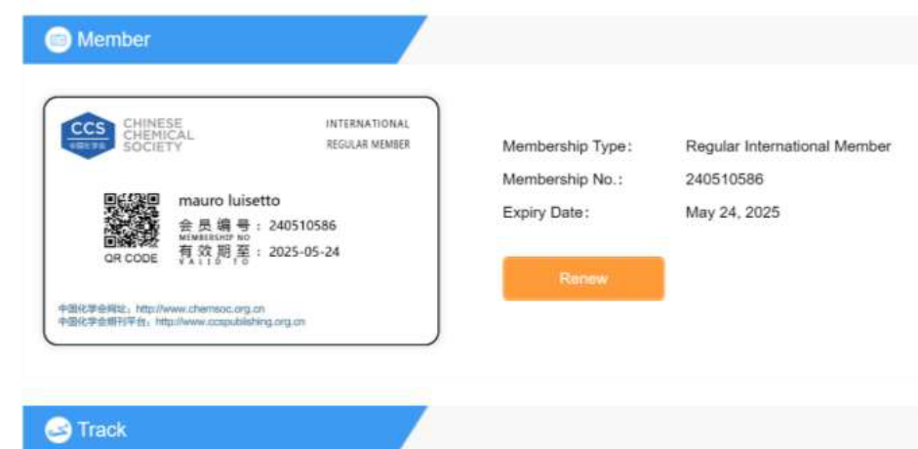

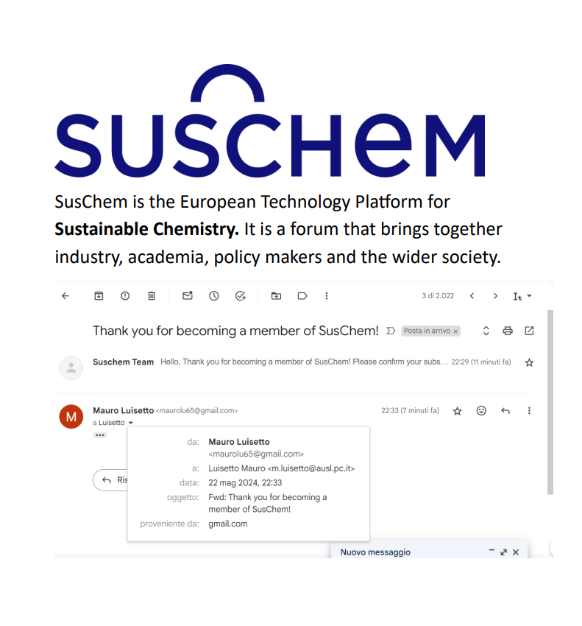
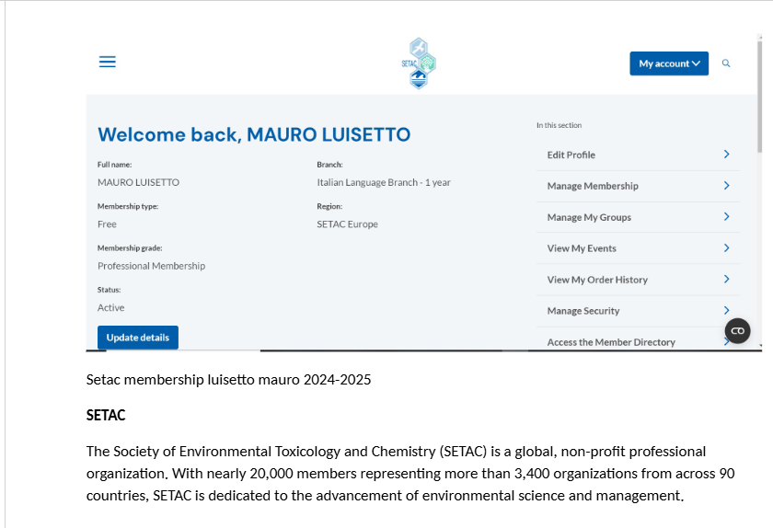

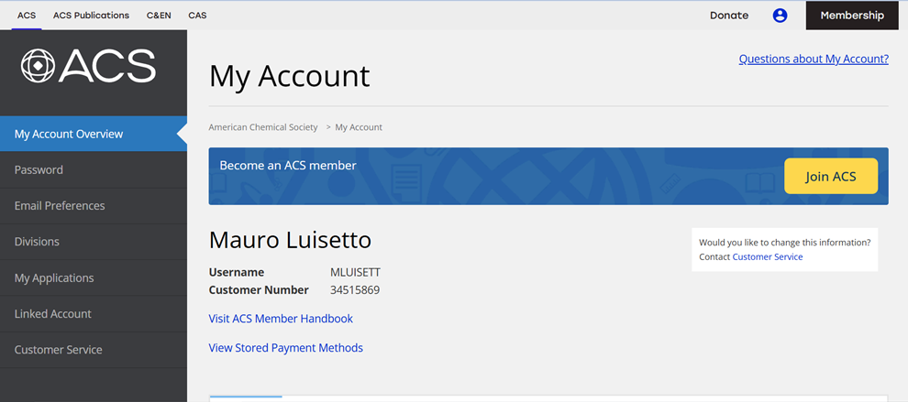
ACS REGISTRATION 2026

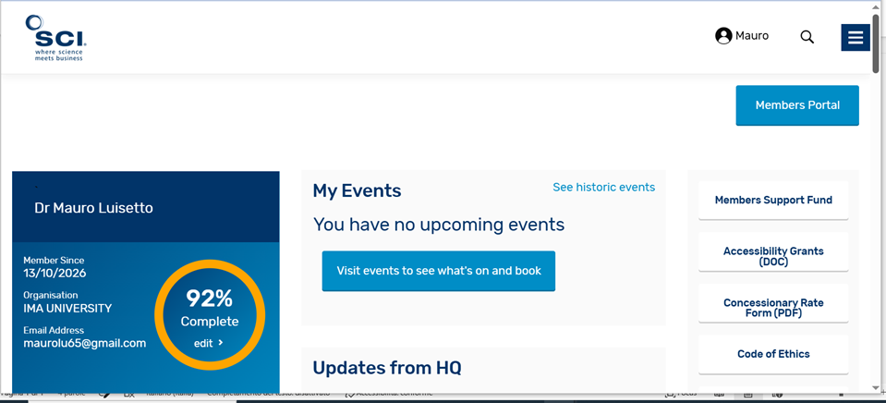
Society chemical industry member n. 243216- expiry data 12/10/2027

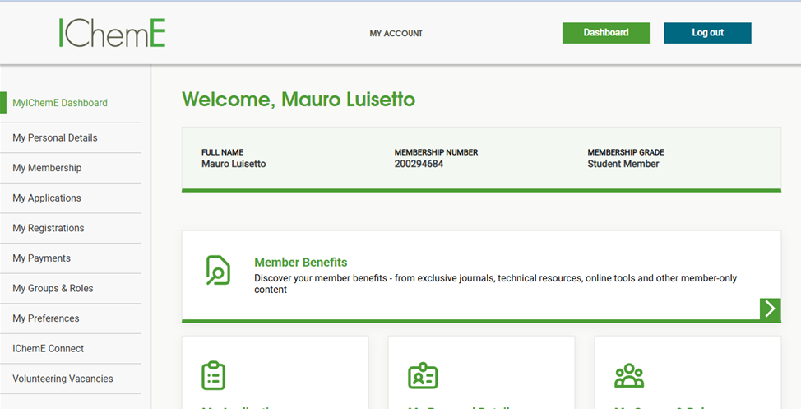
Institution of Chemical Engineers (IChemE)

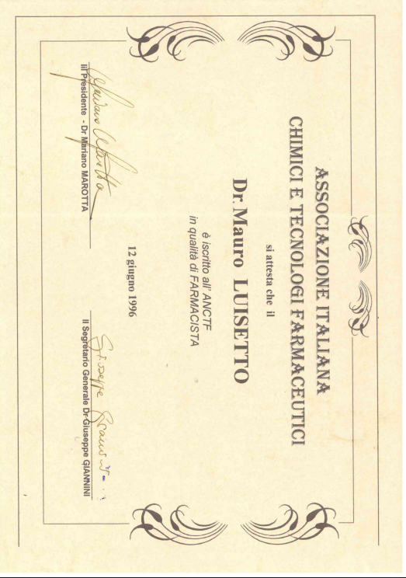
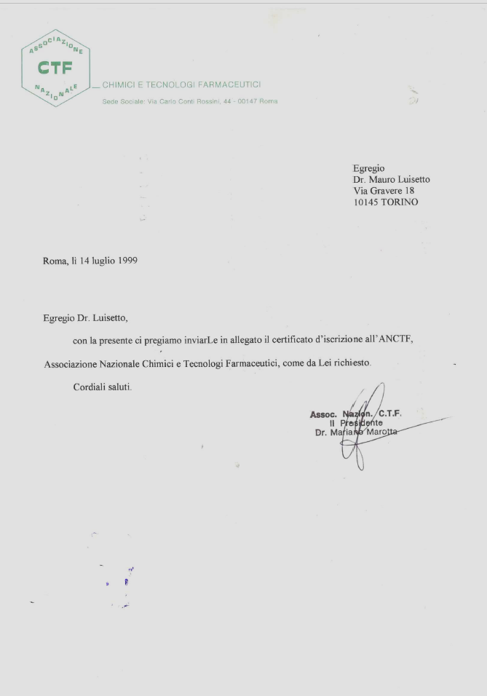
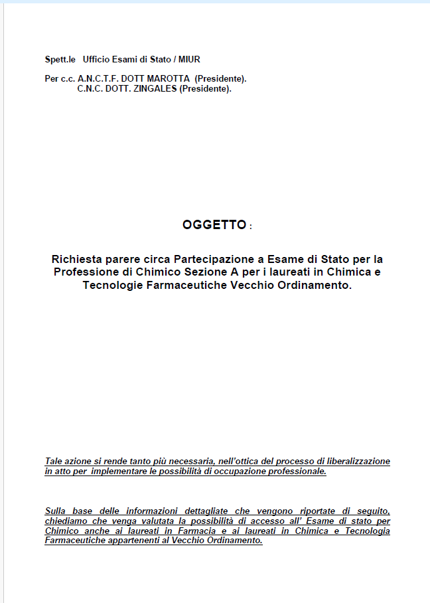

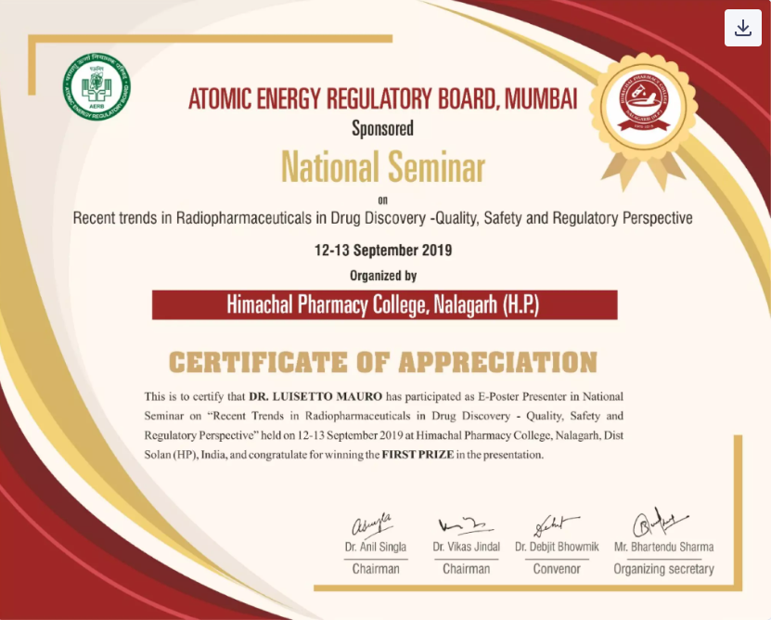
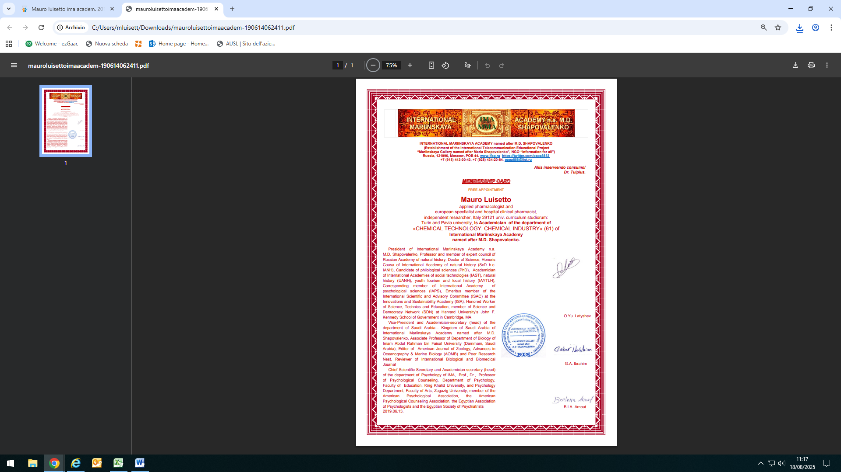
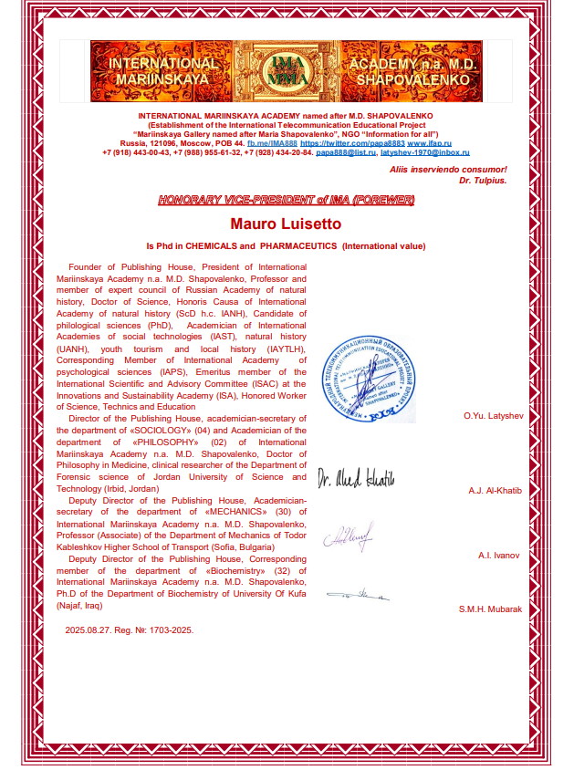
Honorific
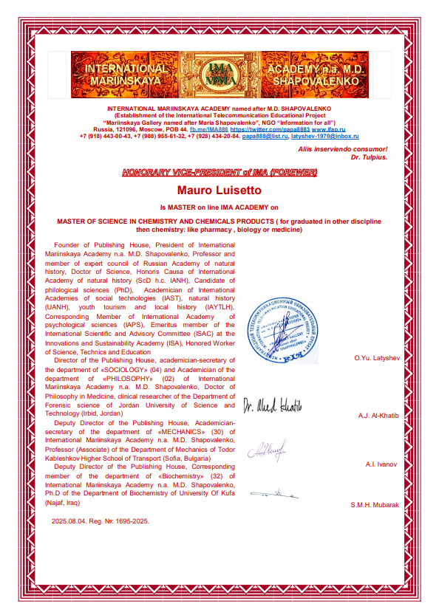
Honorific

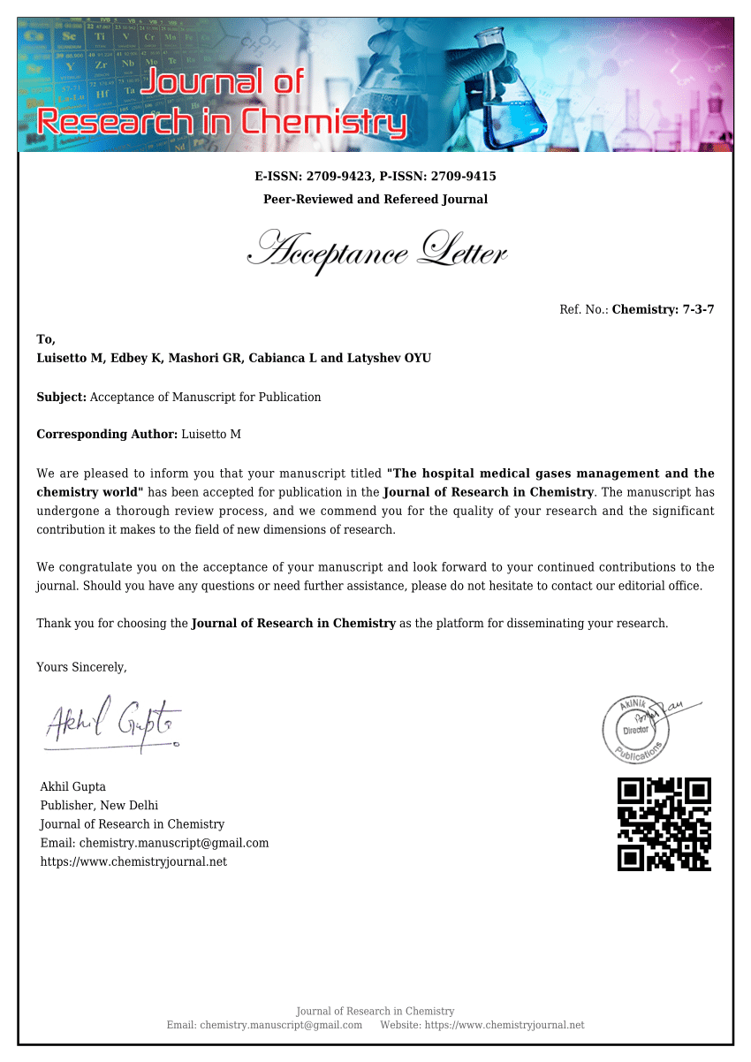

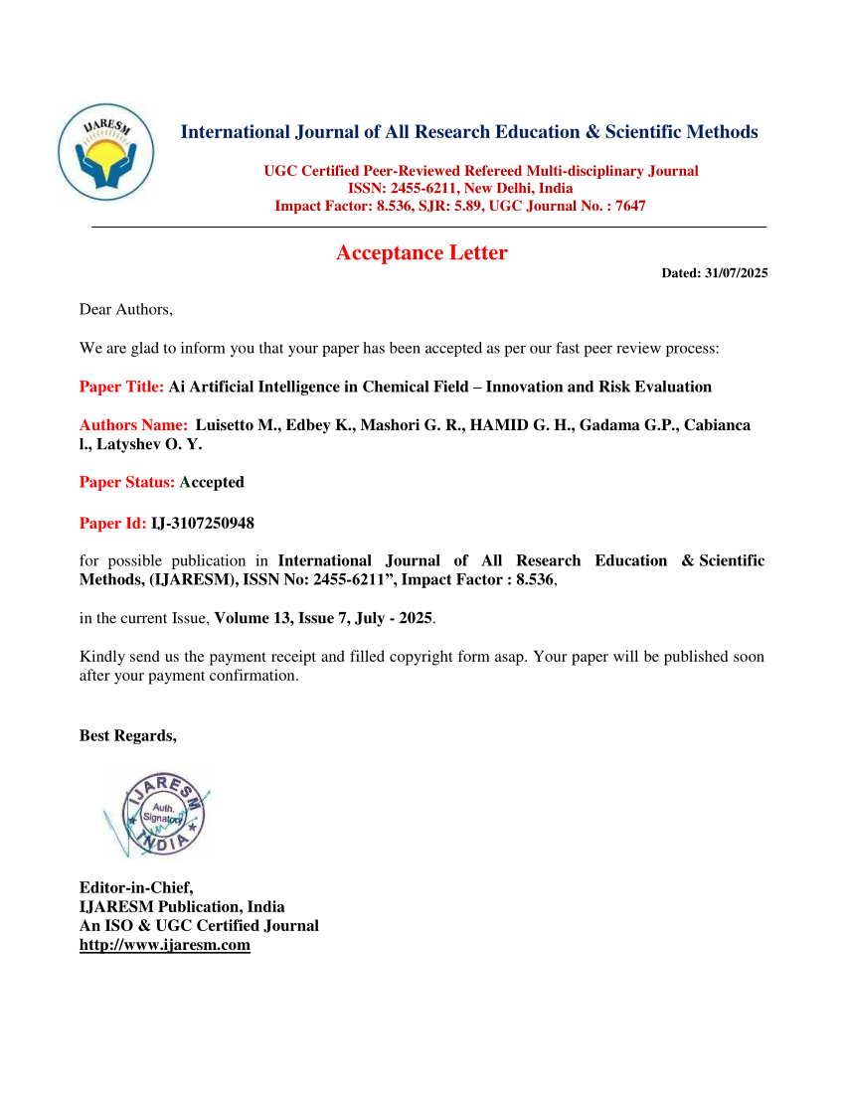

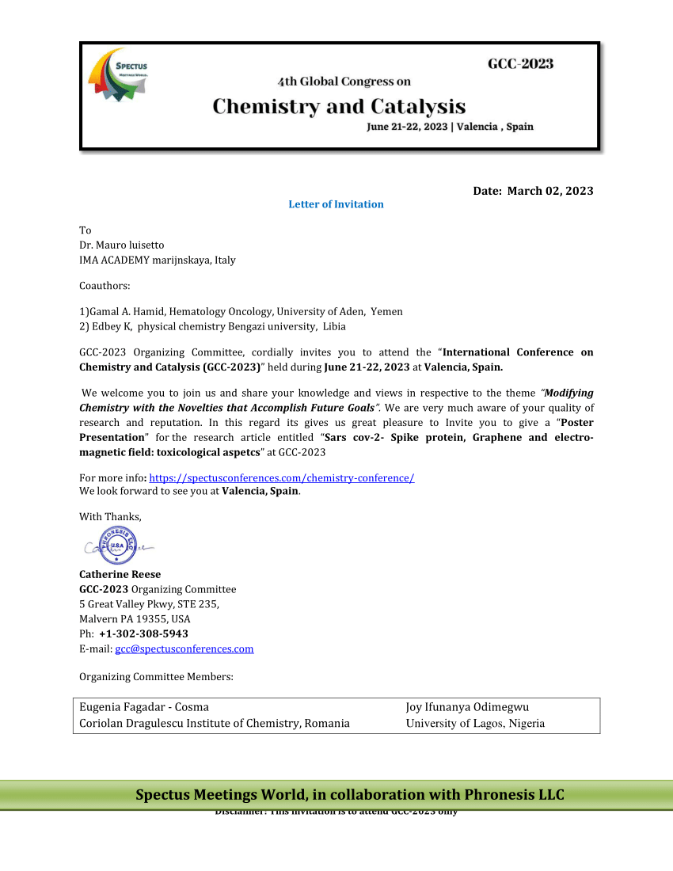
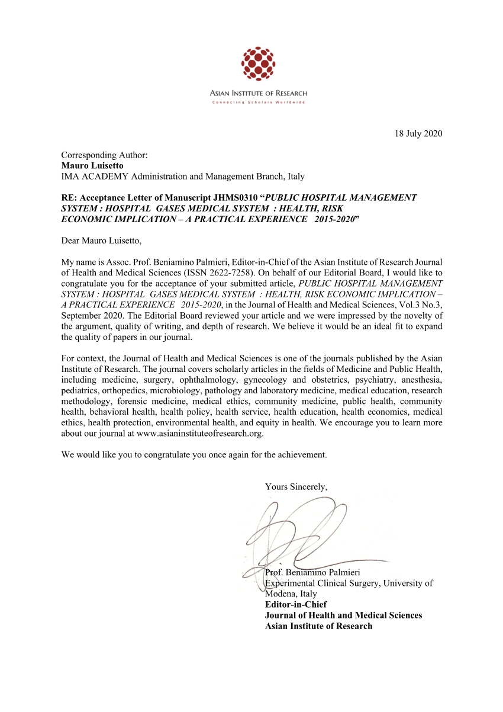
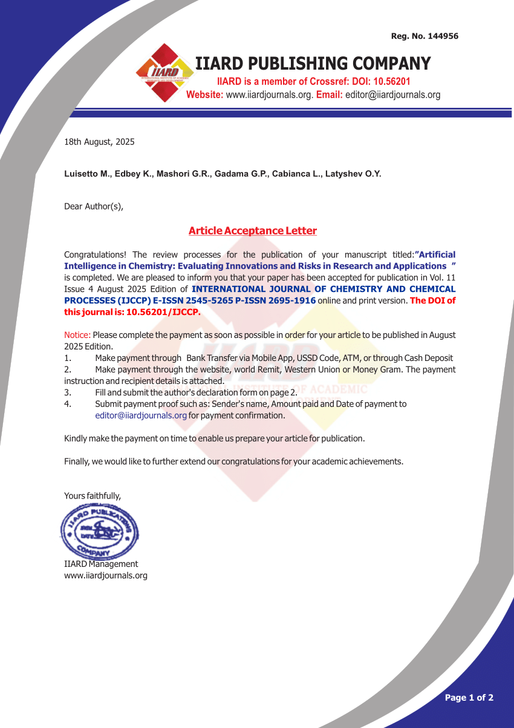

IMA ACADEMY Is an international no profit org affiliated also to the CYPRESS International institute – Malawi satellite QAHE recognized 2026

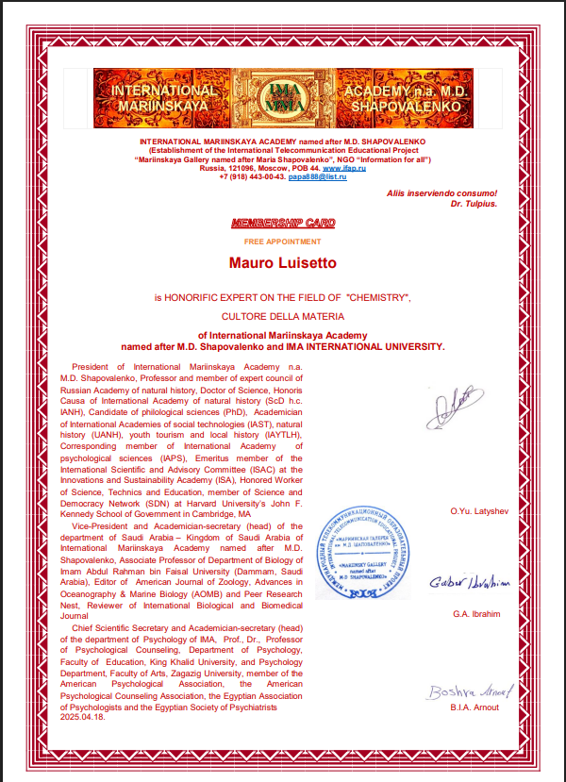

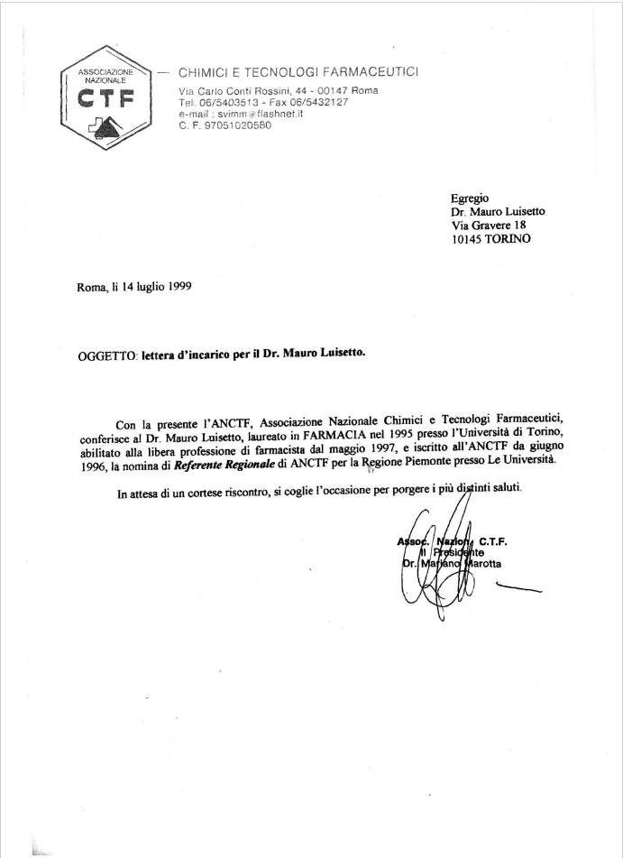

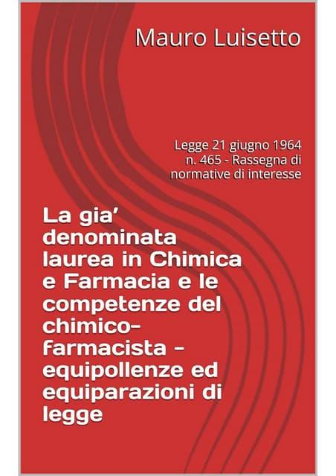

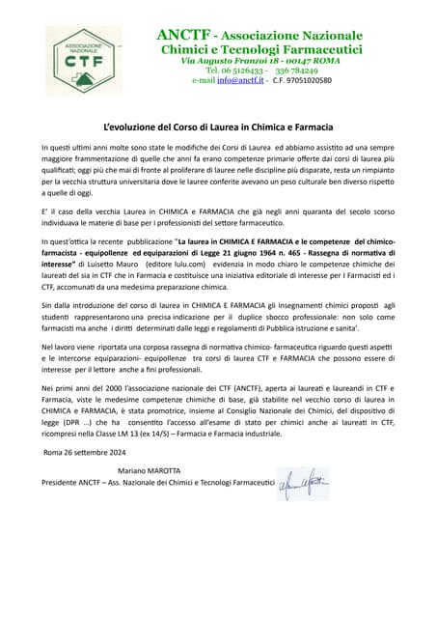
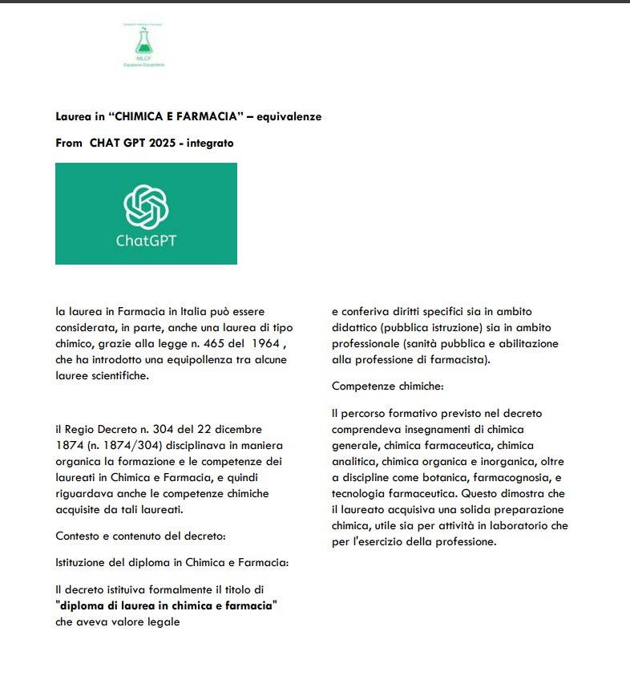
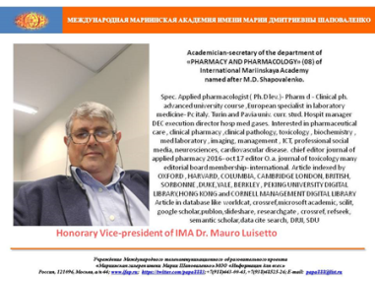
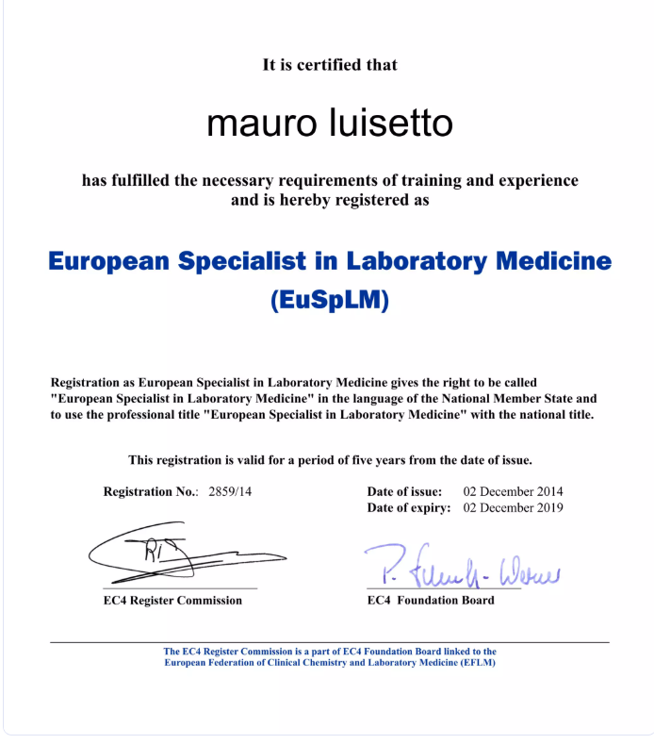

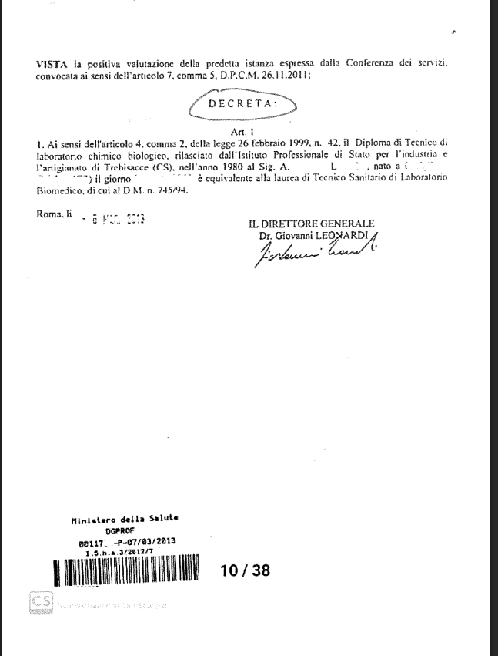
Example of equivalent title: for Diploma di Tecnico Laboratorio chimico e biologico

Doctor Mauro luisetto is 2025 official member of MLCF :
Movement of ITALIAN graduated in “CHEMISTRY and PHARMACY” and equipollent or equiparated title in chemico-pharmaceutical filed
An intellectualium opus org.
Italian translation :Movimento Laureati in CHIMICA E FARMACIA e titoli EQUIPOLLENTI- EQUIPARATI del settore chimico – farmaceutico
Number of registration . 01/18092025
Corso di laurea in Chimica e tecnologia farmaceutiche
Ordinamento e Regolamento Didattico 2025 esempio
Insegnamenti CHIMICI e correlati
CHIMICA GENERALE E CHIMICA INORGANICA
MATEMATICA E PRINCIPI DI STATISTICA
BIOCHIMICA GENERALE APPLICATA E CLINICA
CHIMICA FISICA
CHIMICA ORGANICA I
ANALISI DEI MEDICINALI
BIOLOGIA MOLECOLARE
CHIMICA ANALITICA
BIOCHIMICA GENERALE APPLICATA E CLINICA
BIOLOGIA MOLECOLARE
ANALISI CHIMICO - FARMACEUTICA I
PHYSICAL METHODS IN ORGANIC CHEMISTRY
CHIMICA FARMACEUTICA I
CHIMICA ORGANICA II
CHIMICA FARMACEUTICA II
FOOD CHEMISTRY
LABORATORIO DI PREPARAZIONE ESTRATTIVA E SINTETICA DEI FARMACI
TECNOLOGIA E NORMATIVA DEI MEDICINALI
CHIMICA FARMACEUTICA II
MEDICINE MANUFACTURING AND REGULATORY AFFAIRS
TECNOLOGIA E NORMATIVA DEI MEDICINALI
CHIMICA FARMACEUTICA II
ASPETTI SINTETICI NELLA PREPARAZIONE DI MACRO E BIOMOLECOLE
BIOMOLECOLE APPLICATE ALLO STUDIO DI SISTEMI BIOLOGICI
ANALISI CHIMICO - FARMACEUTICA II
CHIMICA DEI MATERIALI BIOINORGANICI
CHIMICA FARMACEUTICA III
CHIMICA DEI MATERIALI BIOINORGANICI
PREFORMULAZIONE E SISTEMI A RILASCIO MODIFICATO - VEICOLAZIONE E DIREZIONAMENTO DEI FARMACI
ASPETTI SINTETICI NELLA PREPARAZIONE DI MACRO E BIOMOLECOLE
BASI MOLECOLARI DELL'ATTIVITA' DEI FARMACI BIOTECNOLOGICI
BIOMOLECOLE APPLICATE ALLO STUDIO DI SISTEMI BIOLOGICI
CHIMICA BIOORGANICA
CHIMICA DELLE SOSTANZE ORGANICHE NATURALI
CHIMICA FARMACEUTICA AVANZATA
CONTROLLO DI QUALITA' DI ALIMENTI, PRODOTTI DIETETICI ED INTEGRATORI ALIMENTARI
DIETETICA E NUTRIZIONE PERSONALIZZATA
INTERAZIONI BIOCHIMICHE ALIMENTI-FARMACI
LABORATORY ANIMALS AND ANIMAL EXPERIMENTATION
PIANTE OFFICINALI E PREPARAZIONI FITOTERAPICHE
PRODOTTI COSMETICI
PRODOTTI NUTRACEUTICI - PRODOTTI FITOTERAPICI
TOSSICOLOGIA DEI PRODOTTI FITOTERAPICI ED ERBORISTICI
ASPETTI SINTETICI NELLA PREPARAZIONE DI MACRO E BIOMOLECOLE
BIOMOLECOLE APPLICATE ALLO STUDIO DI SISTEMI BIOLOGICI
CHIMICA BIOORGANICA
CHIMICA DEI MATERIALI BIOINORGANICI
CHIMICA DELLE SOSTANZE ORGANICHE NATURALI
CONTROLLO DI QUALITA' DI ALIMENTI, PRODOTTI DIETETICI ED INTEGRATORI ALIMENTARI
INTERAZIONI BIOCHIMICHE ALIMENTI-FARMACI
NUOVE FRONTIERE DEL DRUG DISCOVERY
PRODOTTI COSMETICI
PRODOTTI NUTRACEUTICI E FUNZIONALI
TOSSICOLOGIA DEI PRODOTTI FITOTERAPICI ED ERBORISTICI
ASPETTI SINTETICI NELLA PREPARAZIONE DI MACRO E BIOMOLECOLE
BIOMOLECOLE APPLICATE ALLO STUDIO DI SISTEMI BIOLOGICI
CHIMICA DEI MATERIALI BIOINORGANICI
CHIMICA DELLE SOSTANZE ORGANICHE NATURALI
CHIMICA FARMACEUTICA AVANZATA
CONTROLLO DI QUALITA' DI ALIMENTI, PRODOTTI DIETETICI ED INTEGRATORI ALIMENTARI
ECONOMIA ED ORGANIZZAZIONE DELLE IMPRESE
INTERAZIONI BIOCHIMICHE ALIMENTI-FARMACI
MEDICINE COMPLEMENTARI ED INTEGRATIVE
NUOVE FRONTIERE DEL DRUG DISCOVERY
CHIMICA DEI MATERIALI BIOINORGANICI

Materie di insegnamento previste per le lauree in chimica e farmacia ed equiparate od oggetto di bandi di concorso o previste nei piani di studio ( esempi storici od attuali) :
MERCEOLOGIA, GEOLOGIA, MINERALOGIA, CHIMICA DI GUERRA , ESERCIZI DI FISICA SPERIMENTALE CON STRUMENTI DI MISURA , CHIMICA FISICA , TERMODINAMICA ED ELETTROMAGNETISMO , ELETTROCHIMICA ,CHIMICA APPLICATA, ARGOMENTI DI CHIMICA INDUSTRIALE ( VEDERE CONCORSI PER CHIMICO DELLA MARINA O DELLE DOGANE) , IMPIANTI DELL’INDUSTRIA CHIMICO- FARMACEUTICA, CHIMICA INORGANICA , CHIMICA ORGANICA , METODI FISICI IN CHIMICA ORGANICA , CHIMICA ANALITICA , CHIMICA BIOLOGICA, BIOCHIMICA CLINICA , CHIMICA DEGLI ALIMENTI E PRODOTTI DIETETICI, CHIMICA BROMATOLOGICA , ANALISI CHIMICA QUALITATIVA E QUANTITATIVA , ANALISI CHIMICO STRUMENTALE ,CHIMICA COSMETOLOGICA, TECNICA DELL’INDUSTRIA FARMACEUTICA , IMPIANTI DELL’INDUSTRIA FARMACEUTICA , BIOCHIMICA APPLICATA , ANALISI CHIMICO CLINICHE ,LABORATORIO DI PREPARAZIONE ESTRATTIVA E SINTETICA DEI FARMACI
ed altri insegnamenti secondo piani di studio delle varie universita’ italiane ( FOOD CHEMISTRY,TECNOLOGIA E NORMATIVA DEI MEDICINALI,ASPETTI SINTETICI NELLA PREPARAZIONE DI MACRO E BIOMOLECOLE,CHIMICA DEI MATERIALI BIOINORGANICI ), CHIMICA DEI POLIMERI DI INTERESSE FARMACEUTICO, CHIMICA DEI MATERIALI, CHIMICA DEGLI INQUINANTI , CHIMICA INDUSTRIALE , ZOOCHIMICA .

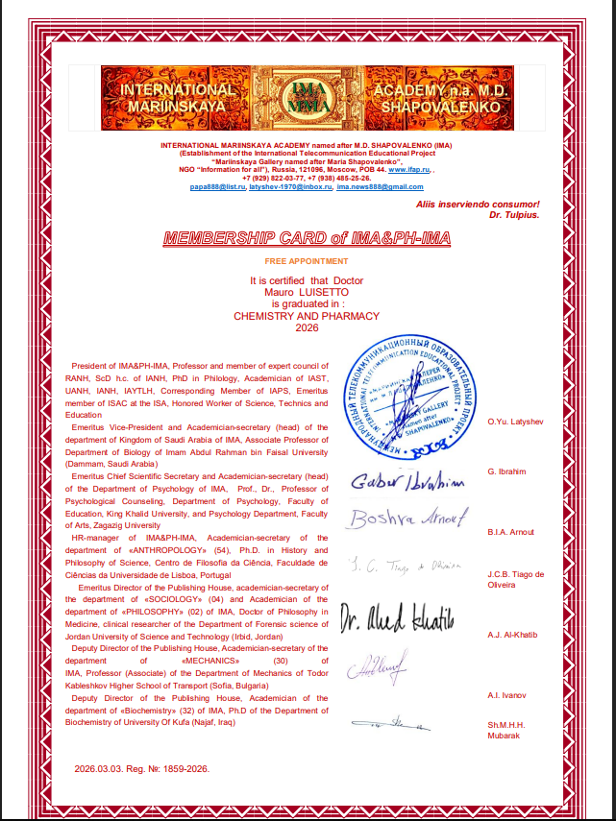
Honirific

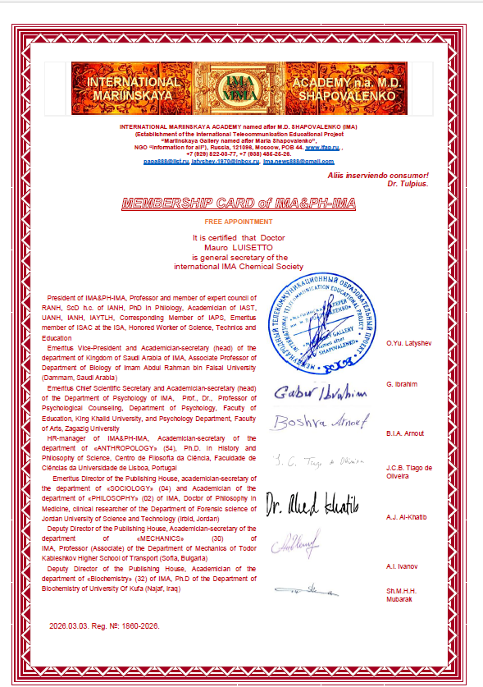

WEBSITE Researchgate,linkedin Facebook, slideshare
Maurolu65@gmail.com italy
MY BIBLIOGRAPHY NCBI NIH https://www.ncbi.nlm.nih.gov/sites/myncbi/1tSnsiCTjimIf5/bibliography/public/
(and in other public collections line publons )
Research Interest Score is higher than 99% of ResearchGate members.
Independent researcher
Turin , Pavia and Parma university curriculum studiorum
Honorific titles from : WAMS , CYPRESS international institute , IMA academy , Saint George school
TITLE A statistical evaluation of reference values of blood cholesterol and bis byproducts in group of Turin population Luisetto, M.; Martelli, A.; Poletti, T., 1996: A statistical evaluation of reference values of blood cholesterol and bis byproducts in group of Turin population. Rivista Di Scienza Dell'Alimentazione. 25(2): 145-149 pubblication- BRITISH LIBRARY INDEXED, BERKELEY UNIVERSITY LIBRARY INDEXED
Specialization Course final thesis – TITLE degree in pharmacy 1995
Statistical analisys concentration plasmatic value about amikacin therapies in hospitalized patients " PAVIA UNIVERSITY 2004
Project work for management course 2021 UNIPARMA : title Analisi osservazionale prospettica del calcolo della quantità di mdc iodato in TC basato sulla massa magra rispetto al peso totale del paziente: preliminare valutazione multicentrica di costi-benefici

PUBLICATIONS indexed by:

PUB MED , My NIH ,HARVARD LIBRARY , BRITISH LIBRARY, CAMBRIDGE LIBRARY. SORBONNE LIBRARY PARIS,LONDON UNIV. LIBRARY , COLUMBIA UNIVERSITY LIBRARY, YALE UNIV. LIBRARY,STANFORD, OXFORD UNIVERSITY LIBRARY, BERKELEY INIV. LIBRARY,PEKING UNIV. LIBRARY , HONG KONG UNIV. LIBRARY, Stockholm University Library, Gothenburg University Library, JOHN HOPKINS UNIVERSITY LIBRARY, Georgetown university indexed,THE WASINGTHON UNIV. LIBRARY MANAGEMENT CORNELL UNIVERSITY LIBRARY, DUKE UNIVERSITY LIBRARY, PENSILVENIA UNIVERSITY LIBRARY SCILIT, REFSEEK, RESEARCHGATE, GOOGLE SCHOLAR, INDEX COPERCNICUS ,CROSSREF, PUBBLONS, MICROSOFT ACADEMIC, DATACITE SEARCH , SDU, IDEAS RePec- ECONOMIC research DIGITAL LIBRARY, LENS.ORG, SCOPUS,SSRN-ELSEVIER, MIT SLOAN SCHOOL OF MANAGEMENT LIBRARY ,VU AMSTERDAM UNIVERSITY LIBRARY, SCIENCEGATE, KING’S LONDON COLLEGE, SCINAPSE, KOREA UNIVERSITY LIBRARY, PRINCETON UNIVERSITY LIBRARY, MIT LIBRARY, BASE INDEXING, , GLOBAL MEDICAL INDEXING WHO- EUROPUB , INTERNET ARCHIVES SCHOLAR – Aminer AND OTHER



